**Applied Cloud Computing ASSIGNMENT 1**

* **Sri Ananya Kondiparthy**

**Project Deliverables**

**1.1 Screenshot of the EC2 instance description which shows instance state,  Instance type, Availability Zone, Security Groups, Public DNS(ipv4). (6pts)**

**1.2 Screenshot of the welcome page after your SSH to the EC2 instance which shows system information as System load, Usage, Memory, Swap etc.  (6pts)**

 1.3 **Write down your Public DNS(ipv4) and Availability Zone. (2pts)**

**Public DNS (IPv4):** ec2-52-53-218-220.us-west-1.compute.amazonaws.com

**Availability zone** : us-west-1c

**1.4 Attach your index.html file, screenshot of your browser at step 15 (6pts)**

**ON TERMINAL:**

**ON BROWSER:**

2.1 Explain what is **security group**. We created a new security group that consists of SSH and HTTP rule. What are the default ports for SSH and HTTP in respect? Is the HTTP rule a must in this assignment? **(4pts)**

* AWS security groups are linked with Amazon Elastic Compute Cloud (EC2) instances. They provide security at the port and protocol level and filter the traffic coming in and out of EC2 instance using a set of rules.

Security groups in AWS is like Firewall in Traditional web architecture.

* The default ports for **SSH** connections is **port 22** for TCP protocol
* The default port for **HTTP** connections is **port 80** for TCP protocolHTTP inbound connections are accepted by the Tomcat Web Server on this port.
* Yes, The HTTP rule is a must for this assignment because HTTP gives unrestricted access to the ports. We are using HTML here that needs HTTP request to deliver content and services. HTTP inbound connections are accepted by the Tomcat Web Server on this port.

2.2 what is **availability zone**? What availability zone do you choose for your ec2 instance and why? **(4pts)**

**Availability zone is an isolated location inside a region. Every region consists of multiple availability zones and each of them are connected via low-latency links as shown in the picture**

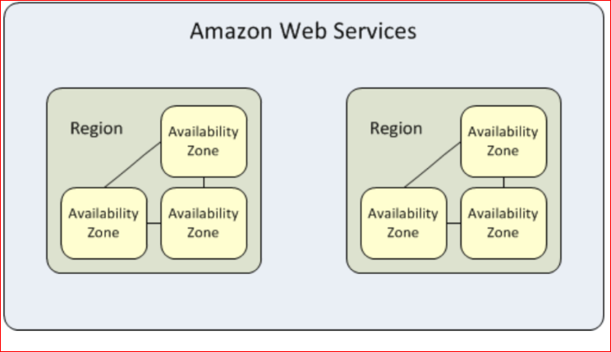

**If there is an natural disaster in one of the availability zone, the data can be transferred to another availability zone so project is continued.**

**Currently there are 10 Regions across the globe in which 3 regions are in U.S.A**

* **The** availability Zone **which I chose for this EC2 instance is**

Availability zone - **us-west-1c**

**Why ? -** I created this instance in USA, California. It is a general rule that usually resources closer to the user are better and faster. The USA west zone is the closer zone for me than the other zones. So I chose this.

2.3 We change the key pair file mode using the command "chmod 400 aaa.pem". What is the meaning of 400? What if we do not change the file mode? **(4pts)**

**Chmod 400 command sets permission for the user to read the file only (can’t write , can’t execute) When we want to connecting using SSH client, We use chmod 400 command to make sure that the private key in the file is not publicly viewable**

* **If we dint change the file mode then users will be restricted to write or execute files. It restricts or limits the permission of users as it is in read mode.**

  2.4 We are using AWS free tier instances. How many free hours do we have in total? Explain what is **AMI** at step 4?

AWS free tier instances are for 750 hours in total each month for one year. Only EC2 micro instances are within Free Tier.

An Amazon Machine Image (AMI) provides the information required to launch an instance. You must specify an AMI when you launch an instance. You can launch multiple instances from a single AMI when you need multiple instances with the same configuration. You can use different AMIs to launch instances when you need instances with different configurations.

An AMI includes the following:

* One or more EBS snapshots, or, for instance-store-backed AMIs, a template for the root volume of the instance (for example, an operating system, an application server, and applications).
* Launch permissions that control which AWS accounts can use the AMI to launch instances.
* A block device mapping that specifies the volumes to attach to the instance when it's launched.

2.5 in step 14 why do we need to use **sudo**? If you are not allowed to run the http server with sudo, but still you want to browse your web page in the browser, what should you do?**(4ps)**

The purpose of sudo is to execute the command given to it with root privileges. sudo is an abbreviation of “super user do” and is a Linux command that allows programs to be executed as a super user (as known as root user) or another user.

The sudo command allows the user to run programs with the security privileges of another user (by default, as the superuser).  It prompts for the personal password and confirms the request to execute a command by checking a file, called sudoers, which the system administrator configures.

By default, the password for the user "root" (the system administrator) is locked. This means we cannot login as root or use su. Instead, the installer will set up sudo to allow the user that is created during install to run all administrative commands. This means that in the terminal we can use sudo for commands that require root privileges. All programs in the menu will use a graphical sudo to prompt for a password. When sudo asks for a password, it needs your password, this means that a root password is not needed. To run a command which requires root privileges in a terminal, simply prepend sudo in front of it. To get an interactive root shell, use sudo -i.

**To Run HTTP Server Without Sudo:**

When I tried to run a HTTP Server without using SUDO command it displayed an error message that says, “Permission Denied.” The other way is to use the Port number greater than 1024 and change in the settings in the security group and then run the browser.

Network ACL inbound rules allowing traffic on ephemeral ports (1024-65535)